COSC 1436 - Assignment 2

## 1. Brief Introdunction to Pygame Zero:

We are going to use Pygame Zero for Assignment 2. For this assignment, we need 2 more main things from Pygame Zero with five concepts from Assignment 1:

* Actors or sprites (Declaring, accessing properties, and calling the behavior).
* Text drawing on the screen.

When you think of any video game, what is one of the important elements in it? These are the game characters, whether they are the enemy characters or the main player. What is unique about these characters is the ability to move, and do various things throughout the game. These are referred to ***Sprites***, and they constitute all of the non-static parts of the game. In this class, we will call the different types of game characters(sprites) *Actors*. Each actor will have their unique properties and behaviors:

* Properties: are values that uniquely describe the character. Properties are implemented through the use of variables.

* When you create a new actor, Pygame Zero provides four default properties that you can use and modify.

|  |  |
| --- | --- |
| **Property** | **Meaning** |
| actorName.image | A string variable that stores the image name. |
| actorName.x | A float variable that stores the x-axis position where the center of the image will be displayed on the screen. |
| actorName.y | A float variable that stores the x-axis position where the center of the image will be displayed on the screen. |
| actorName.pos | A tuple of two float variables that stores the x and y coordinates. |

* Behavior: are actions(functionalities) that an actor can do. Behavior is implemented through the use of functions.

In Pygame Zero, we declare an ***Actor*** using the following instruction:

***player1 = Actor(“xxxxx.png”, (x_position, y_position))***

We access the property of an ***Actor*** using the following instruction:

***actorName.property = value***

e.g. player1.x = 0

player1.y = 10

player1.time = 100

As you can see, this is similar to declaring new variables in Python. The only difference is that the variable name is preceded by the actor and the period(.) operator.

We call the behavior of an ***Actor*** using the following instruction:

player1.draw()

Pygame Zero also allow us to draw text on the screen by using the following instruction:

***screen.draw.text(“text”, (x,y), fontsize = 30, color = “name”, background = “name”)***

*For this function, you can skip font size, color, and background, then the function takes default arguments for them.

## 2. Assignment Description:

In this assignment we are setting up the screen to look like the following Mortal Kombat (1992) game.

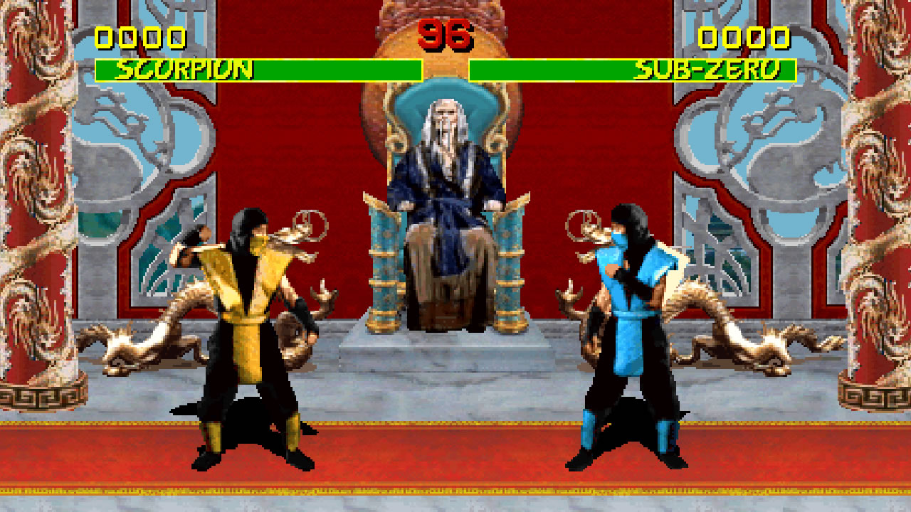

## Assignment Questions:

1. Declare the *fight* Actor (Sprite).

- This actor will be the background of the game and it will have two parameters(***time*** and ***maxHealth***)

- We will use the image of ***‘shang stage full.png’*** under the images folder.

- The x-position is 500 in integer, and y-position is 200 in integer.

- Declare two properties called ***time*** with 99 integer value and ***maxHealth*** with 100 integer value.

1. Declare the *Player1* Actor (Sprite)

- We will use the image of ***‘p1idle0.png’*** under the images folder.

- The x-position is 0.2*WIDTH and y-position is 0.58*HEIGHT.

- Declare three properties called ***name*** with SCORPION of string value, ***health*** with 100 of integer value, and ***score*** with 0 of integer value.

1. Declare the *Player2* Actor (Sprite)

- We will use the image of ***‘p2idle0.png’*** under the images folder.

- The x-position is 0.8*WIDTH and y-position is 0.58*HEIGHT.

- Declare three properties called ***name*** with SUP-ZERO of string value, ***health*** with 100 of integer value, and ***score*** with 0 of integer value.

1. Draw the Background and Player1 & 2. The screen will look like:

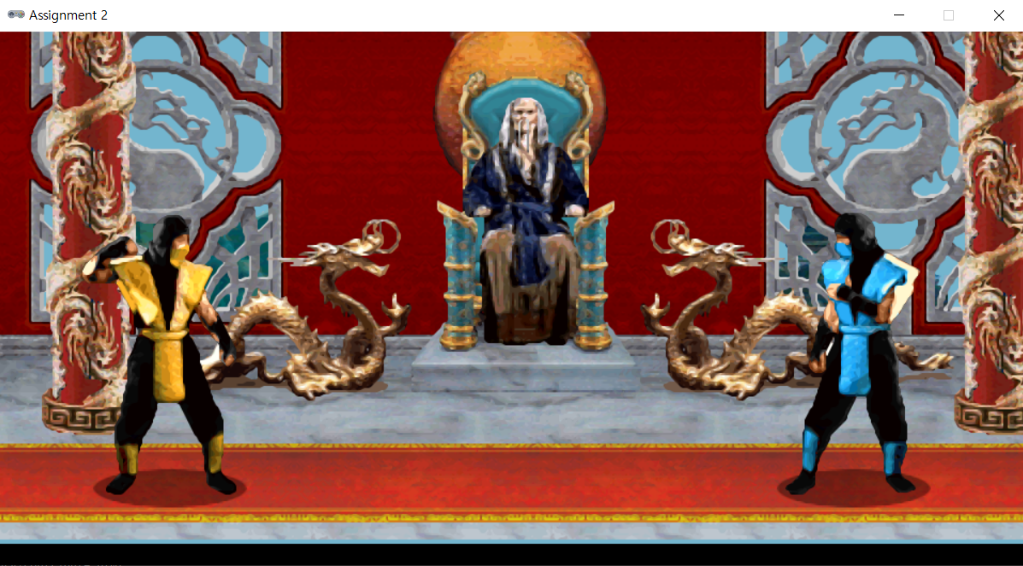

1. Draw the Health bars for Player1 & 2, and put player’s name at the edge of the Health bar.

* When you draw the names, you should use players’ name properties that we declared above instead of using string name.

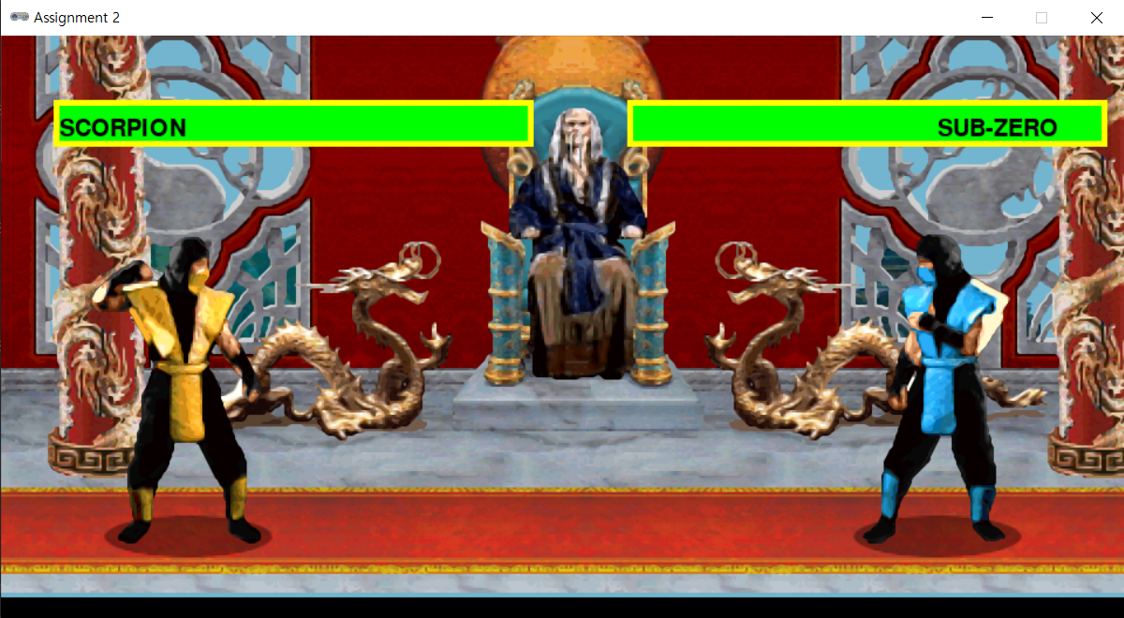

1. Draw the Time and Scores of Player 1 and 2 (for now it will print only constant values).

- The time will be 99 of string value, and the score for each player will be 0000 of string value.

After you are done with your code, the screen should be the following:

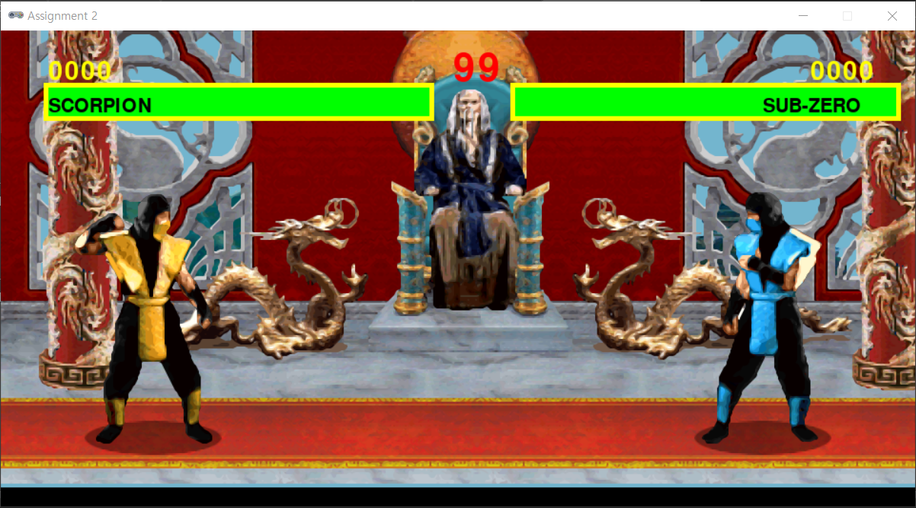

## What to hand in:

Submit your project electronically through D2L by attaching and submitting your Python program file (assignment2.py).